* ***p.2 ex. 3***

1. **Reception:** waiting room, reception
2. **Practice Manager:** practice manager
3. **Doctors:** consulting room doctor A, consulting room doctor B, consulting room doctor C

* ***p.2 ex. 4***

|  |  |  |  |
| --- | --- | --- | --- |
|  | **B** | **C** | **D** |
| **User** | Doctors | Reception staff | Practice Manager |
| **Use** | Use system to access a number of databases | Use specially tailored software | A payroll package |
| **Program types** | System | Program | spreadsheet |
| **Data input** | Patient’s name | All appointment dates and times | Income and expenditure |
| **Output** | Patient’s records | Daily lists of appointments | Calculate salaries |

* ***p. 4 ex. 6 + the diagram***

1. First enter the search criteria by name
2. To find patients, enter Smith in Forename box
3. Select “male” radiobutton
4. Type age from 16 to 50 in textboxes near word “Age”
5. Click on the “Registration” tab
6. Select doctors Warner and Roberts
7. Finally, click on the Find button

* ***p. 5 ex. 7***

1. surname Green
2. find patients
3. search criteria
4. First
5. Selected
6. Then
7. The selection criteria have been entered
8. Finally, see the records

* ***p. 5 ex. 8***

1. OfficeSuite Standard
2. OfficeSuite Small Business Edition
3. OfficeSuite Developer
4. OfficeSuite Standard
5. OfficeSuite Premium
6. OfficeSuite Professional
7. OfficeSuite Premium
8. OfficeSuite Premium

* ***p.7-8 ex. A(1-6)***

1. b
2. remote access to the software and manages the hardware required to run the applications
3. they lease space from data storage specialists
4. office suite applications, email services, complex business applications (enterprise resource planning tools like SAP), payroll and accounting systems
5. As small businesses have the opportunity to use such tools for small periods of time and when they need them, rather than having to buy the software as a permanent investment.
6. Coping with sudden large increases in customers.

* ***p.7-8 ex. B (1-3)***

1. **Advantages:** remote access to the software, managing the hardware required to run the applications, paying for the applications as and when you need them, providing a secure, reliable service which will be available whenever you need it, providing applications and storage space, a wide variety of applications available

**Disadvantages:** to use applications remotely requires a lot of bandwidth

1. **Tables:**
   1. 8
   2. 7
   3. 5
   4. 1
   5. 3
   6. 4
   7. 2
   8. 6
2. **True/false**
   1. **false**
   2. **true**
   3. **false**
   4. **true**
   5. **false**

***Study the game reviews***

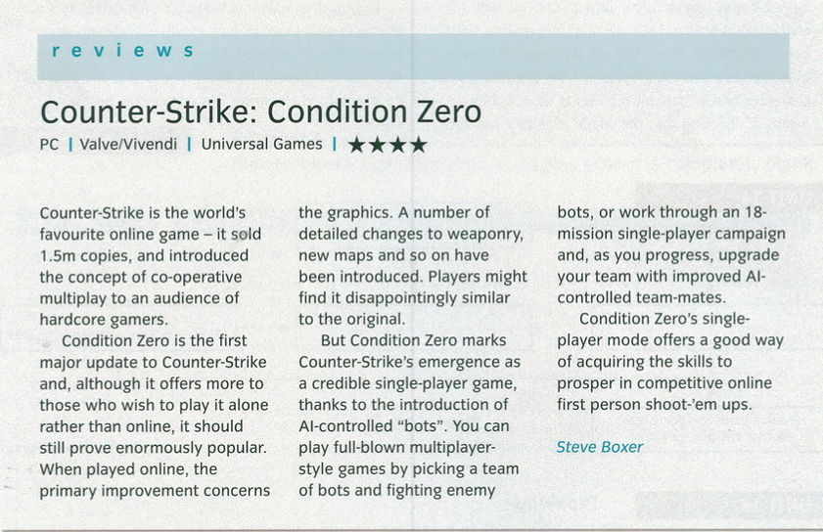

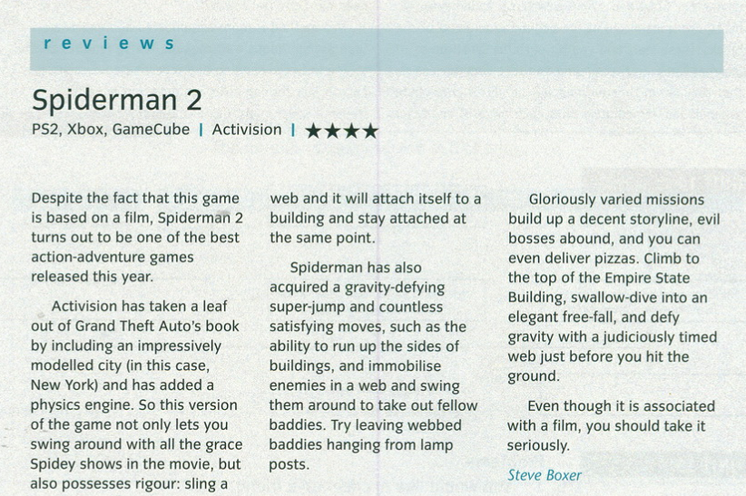

Writing

After reading the text about types of games write your review of a computer game, classify it according to the text’s division, describe and give your point about it:

<https://www.idtech.com/blog/different-types-of-video-game-genres>

|  |
| --- |
| The genre of “Barbie and the Magic of Pegasus” is adventure. I played this game in my childhood and it’s the best game I have ever played. The evil wizard Wenlock has cast a spell turning everyone in the kingdom to stone. Join Annika, her pet polar bear cub, Shiver, and Brietta, a magnificent winged horse, on a fantastic adventure to search for the magical Wand of Light. The wand is the only thing that can break the spell! Play fun games and solve challenging puzzles as you journey through four enchanting locations in search of clues. It’s up to you to find Wenlock and save the kingdom from his evil spell. |

Reading

Follow the link to read the text about the difference between Application Programs and System Programs to be ready to discuss and re-tell:

<https://www.tutorialspoint.com/application-programs-vs-system-programs#:~:text=Some%20of%20the%20common%20application,are%20known%20as%20application%20programs>.

Vocabulary

Study this vocab set on the topic, be ready for vocab check:

<https://quizlet.com/572164087/applications-programs-games-flash-cards/?new>